SourceCode:

#include <iostream>
#include <vector>
#include <ctime>
using namespace std;
vector<int> randomVector()//生成随机数组
{
vector<int> ivInputVec;
srand((unsigned)time( NULL ) );
int num_input_vec = rand()%20;
for(size_t i=0; i<num_input_vec; i++)
{
ivInputVec.push_back(rand()%100);
}
return ivInputVec;
}
vector<int> deleteEvenNum(vector<int> ivVec)//删除偶数
{
vector<int> ivOddVec;
for (size_t i=0; i<ivVec.size(); i++)
{
if (ivVec[i] % 2 != 0)
{
ivOddVec.push_back(ivVec[i]);
}
}
return ivOddVec;
}
int main (int argc, char** argv)
{
//vector<int> ivTest = randomVector();
vector<int> ivTest; //空数组输入测试
if (ivTest.empty())
{
cout << "The input vector is empty!" << endl;
}
else
{
cout << "vector before deleting even number:" << endl;
for (size_t i=0; i<ivTest.size(); i++)
{
cout << ivTest[i] << endl;
}
vector<int> ivTest_after_delete = deleteEvenNum(ivTest);
if (ivTest_after_delete.empty())
{
cout << "The output vector is empty!" << endl;
}
else
{
cout << "vector after deleting even number:" << endl;
for (size_t i=0; i<ivTest_after_delete.size(); i++)
{
cout << ivTest_after_delete[i] << endl;
}
}
}
return 0;
}
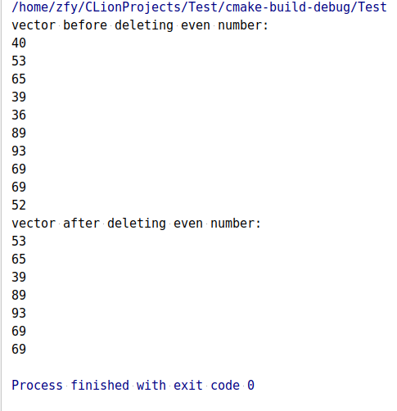
测试用例１：

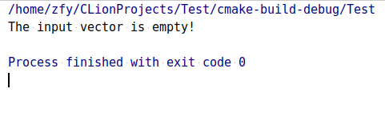
测试用例２：

